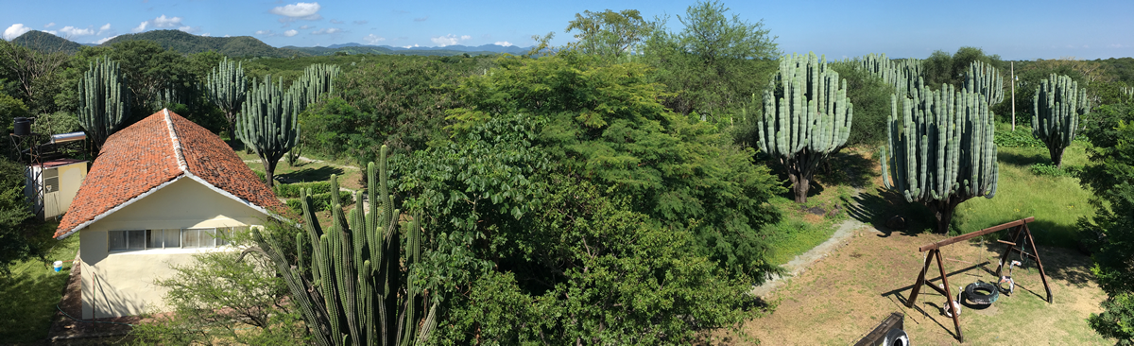

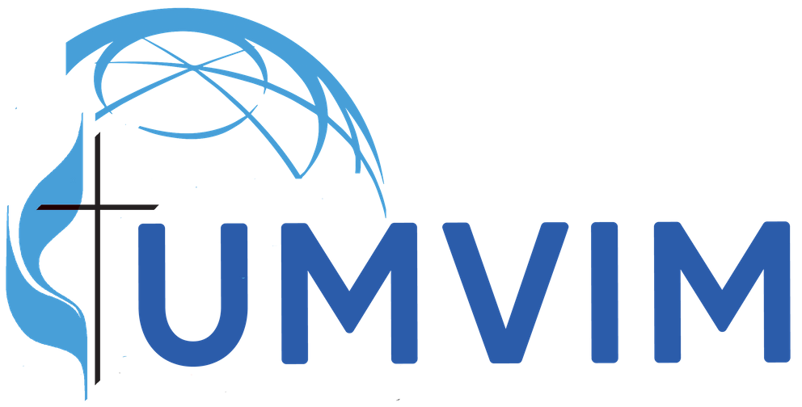
Virtual Mission: Project Name
City, State/Country

Website: [Project’s URL]
Facebook: [Project’s Facebook or other social media page]
Video: [Project’s video link, if available. If not, remove this line.]

Location: Name of city or town, perhaps indication of part of country.

Links to history, highlights, geography, etc. of area.
Have fun researching the area and looking for appropriate information from trusted sites. These can be links to websites, articles, videos, etc.

- Google Maps
- Historical overview
- Major tourist sites
- Videos showing area
- Average weather conditions [Wunderground is a good website]
- Local newspapers
- CultureGrams

Project’s emphasis or ministries
Here you can list the types of ministry or ministries in which your site engages. You could make it a simple list or provide links back to the site’s website if possible. Below is a sample list:

- Migrant worker resources
- Children’s education
- Parenting classes
- Community health clinic
- Food pantry
Suggested readings
Discussion groups are great ways to prepare for a mission or to have deeper reflexion of your service once you return home. You can meet online, through social media, or, if possible, face-to-face. Here are some suggested books related to mission work and the types of ministries at [your site].

Books [Add a hyperlink back to Cokesbury, Amazon, or other bookseller to help people find the books easily and quickly.]
- When Helping Hurts: How to Alleviate Poverty Without Hurting the Poor . . . and Yourself
- The End of Hunger: Renewed Hope for Feeding the World
- Hunger for the Word: Lectionary Reflections on Food and Justice - Year B (Year B: 2020-2021)

Local Involvement

It is crucial to remember that travel to a faraway mission site is not the beginning and end of your mission! It is one portion of your congregation’s expression of Christian love and service to the world. When at home, keep the team unity going through activities that relate to the work at [your site].

- Prepare a meal at your church that is typical to your mission area and share your volunteer story. Do an internet search to find recipes from the area and share the URL link.
- Put together a Spotify playlist of traditional music from the area/country where your site is. Spotify playlists are shareable through a link.
- Connect the types of ministries from your site with the same issues in your own community. Perhaps they are homelessness, hunger, illiteracy, women’s rights, access to healthcare, or child abuse. Become an advocate in your community for these same issues. Volunteer at community agencies that work to correct these injustices.
- Learn the native language where your mission site is! Even if you just learn a few phrases, your efforts will be greatly appreciated by the people there. On the flipside, consider helping immigrants in your community to learn English. Many public libraries have ESL programs that need volunteers.

Skype
Your team can Skype with a staff member of the program! You can do this during a special event or maybe even worship service. Contact the site host for more information.

Donations
Financial donations are always needed and appreciated. Have your team brainstorm on how to raise funds for the mission site even if you can’t travel right now. Here are some ideas:

- If your team has already paid a deposit, consider giving it to them as a donation.
- Tell your congregation about what has happened and the additional burdens on the mission site, then ask for donations.
- Have a special event.
- Ask team members or church members to pledge a certain amount of money each month. A consistent stream of money each month can be very beneficial to the site.

Donations can be sent directly to the site through the Advance if your site has an Advance number. (Remember, when giving through The Advance, 100% of your donation goes directly to the project!) Or, check to see if the program has a PayPal account or other online donation platform.

If there are Global Ministries missionaries connected to the site, consider supporting their salary and/or starting a covenant relationship with them. Donations of any amount are appreciated. Learn how!

Thank you for following God’s call to service with our neighbors!

P.S. Be sure to change the picture on page 1 with one from your site!

